**COMP 125 “Group” Project Proposal**

**Connor Doman**

A karate dojo manager. You can add and view student info for later access. Could be used to set up testing, appointments, and lessons.

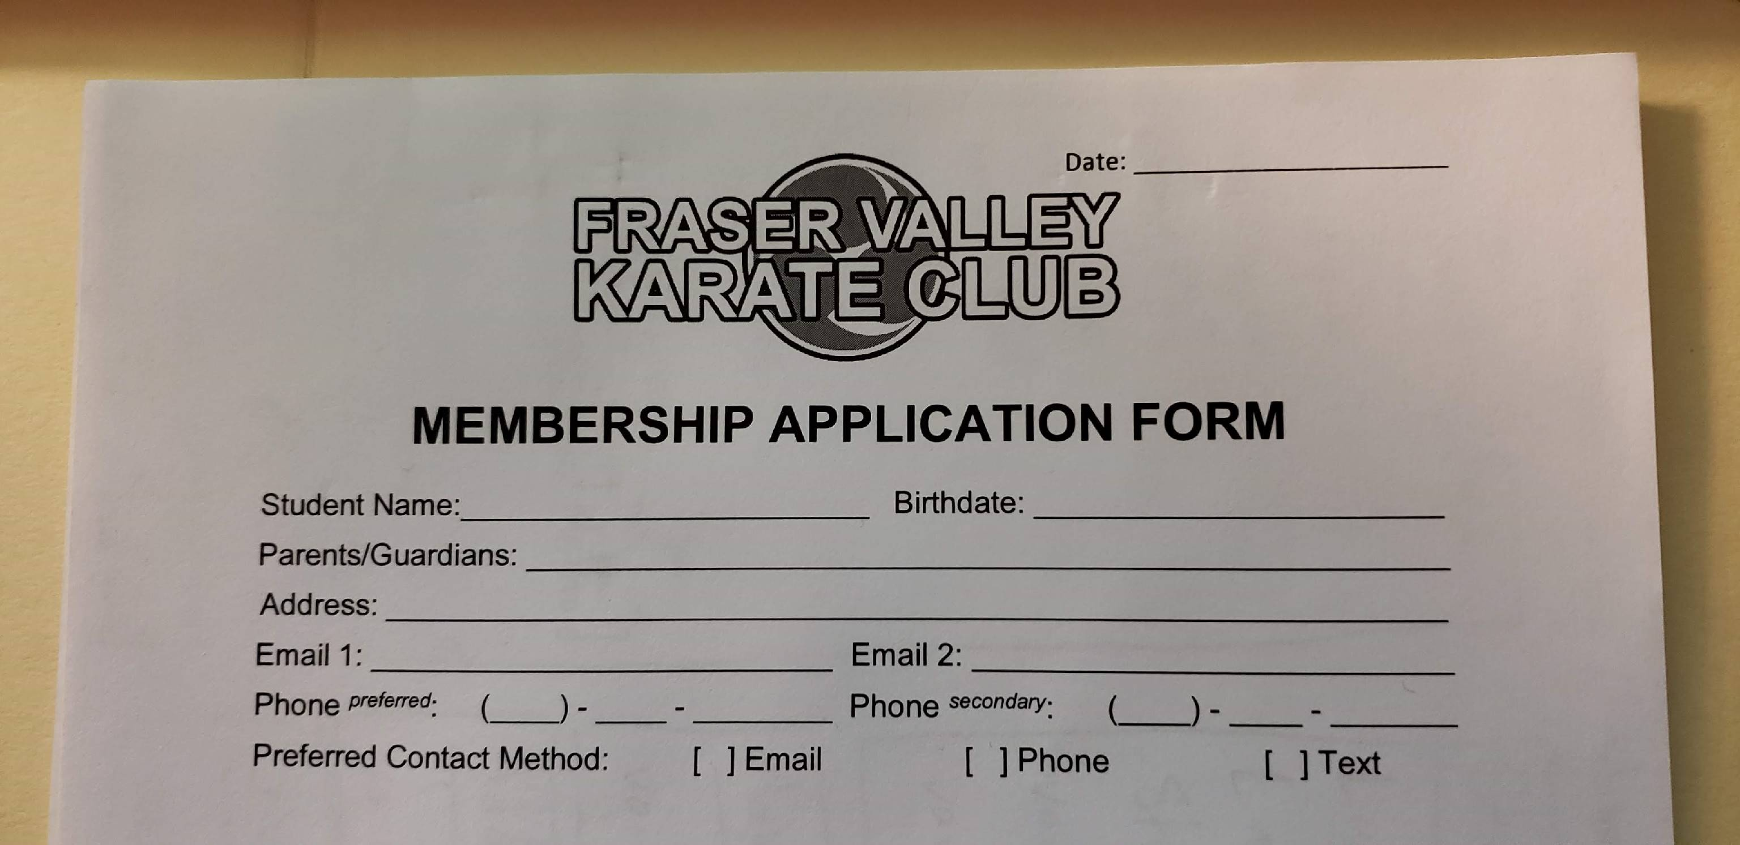

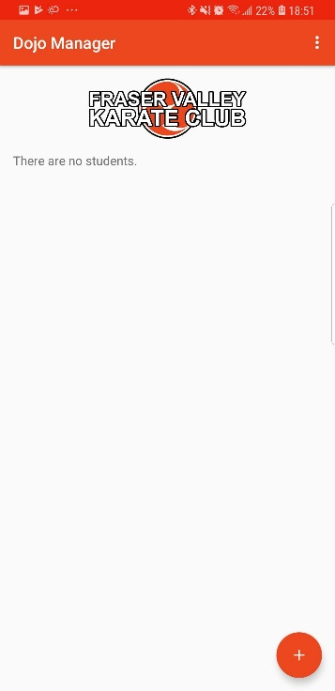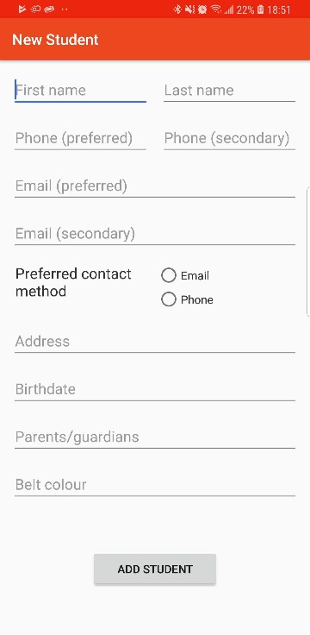

UML follows on the next page.

